Digging Up Obama Hope:

Recovering Digtial Visual History with Media Archaeology

**Introduction**

“The domain obamicon.me is for sale. To purchase, call Afternic.com at +1 781-373-6847 or 855-201-2286. Click here for more details.”

Registering a domain name is a mundane affair. If you click for more details on the Obamicon.me site, you will be re-directed to form where you can enter your personal information, prove you are not a robot, and get a price quote for the domain within 24 hours. What you will not find is anything about the history of what used to be available at Obamicon.me, a once active website that Laurie Gries argues was largely responsible for the mass production *Obama Hope* remixes that began to widely circulate in 2009 (*Still Life with Rhetoric*). It is unsurprising that Obamicon.me is now defunct—with the average lifespan of a website estimated around 100 days, a lot of content goes offline (Lepore). Web users encounter this phenomena in the form of broken links (often marked with error messages or solicitations to purchase such as the offer above), automatic redirects to a different website (which is what would have happened if you had attempted to access the Obamicon.me URL back in 2016), or new content written over the old (what would happen if you purchased the domain and created your own website). In the face of such instability, often termed *reference rot* or *link rot*, you must look elsewhere to understand what Obamicon.me was and what happened to it.

*Paste Magazine* conceived of Obamicon.me in late 2008, a few months before the United States presidential election (Paste Staff, “The Return of Obaicon: Create Your Own Image”), and launched the site January 7, 2009 with the message “Regardless of your candidate of choice in the 2008 election, here's your chance to sound-off" (Paste Staff, “Paste Launches Obamicon.Me”). The site allowed visitors to create and share customized Obamicons, images designed in the vectorized style of Stephen Fairey’s Obama Hope poster. To create on Obamicon, visitors would upload a photo or taking one with a webcam, adjust the color levels, and insert a custom caption at the bottom of their own digital design (see Fig. 1). Once complete, visitors would have the option to save their Obamicon to their computer, share it directly through social network sites such as Facebook or Twitter, or upload it to the gallery on the site where other visitors could interact with the image by rating it on a scale of one to five or leaving a comment (see Fig. 2). As the announcement for the site urged: create, browse, rate or comment (Paste Staff, “Paste Launches Obamicon.Me”).

And people did. Within a week, the site had generated over 1.5 million views and 40,000 Obamicons, drawing in higher traffic than the monthly average for Paste’s primary website. Paste editor Josh Jackson explained that Obamicon.me “was officially bigger than our magazine site,” and the image generator was later credited as part of the magazine’s successful business strategy of “generating buzz and traffic for a small, 180,000-cicrc[1] [sic] magazine in a tough independent music market” (FOLIO: Magazine Staff). As part of this business strategy, the bottom of the Obamicon.me site featured a banner advertisement with an invitation to learn more about *Paste Magazine,* along with a trial subscription offer. *Paste* also partnered with online vendor Zazzle to offer visitors the ability to print their custom Obamicons on items ranging from T-shirts to coffee mugs (Duffy; Paste Staff, “The Return of Obaicon: Create Your Own Image”). To promote the Obamicon.me service, *Paste* launched a designated Facebook Page on 18 January 2009. Judging from the engagement levels on the oldest public posts, along with the low number of Likes and Follows on the page, few initially listened (@ObamiconMe). Similarly, a company Twitter account shared news coverage of the service and relevant announcements, such as upgrades to the site’s server in response to heavy traffic leading up to the presidential inauguration (@ObamiconMe). Such traffic resulted in the eventual creation of millions of Obamicons.

With site traffic peaking around the time of the inauguration, it is clear that part of Obamicon.me’s appeal was tied up with politics and current events. However, even that appeal is not so straightforward. Despite the name of Obamicons, *Paste* framed the purpose of the site around self-expression and creativity rather than political messaging—a frame that echoed in the media coverage of the viral phenomenon of remixed Obama Hope images. For example, online news sites and blogs that featured galleries of Obamicons typically selected images for humor or aesthetic qualities rather than political commentary (e.g., Marino; *The Telegraph*; Yoo). These featured Obamicons tended to draw upon figures from popular culture, such as Yoda from Star Wars and David Bowie, or Internet staples, such as Rick Astley and cats.[2] Despite the dominance of popular culture and internet references, political themes did appear, with variations of Obama’s image and the message of hope, such as the zombie Obama (Gries, "Obama Zombies and Rhetorical (Dis)Identifications"), and the satirization of popular U.S. political figures, such as John McCain, Sarah Palin, and Bill Clinton. People also used the Obamicon generator to modify photos of themselves, their friends, family, and pets (Mackey; Gries, "Obama Zombies and Rhetorical (Dis)Identifications"). Whether used as a venue for creativity or a good way to waste time, as a tool for political expression or provoking a small chuckle, Obamicon.me offered an ambivalent outlet. To the question posted on the official Facebook page—“Can I like Obamicons and dislike Obama?”—the answer seems to have been a resounding *yes*.

After the inauguration, the site continued to evolve both in form and offerings. Some of the changes involved making the image generators, in Obamicon.Me creator and *Paste* co-founder Tim Regan-Porter’s words, “white-labeled for clients” (Regan-Porter). To white-label a product or service is to rebrand it so as to seem like a creation of the client company. Such white-labeling included the Green for All image generator, designed for the non-profit of the same name, and a sports image generator for the Atlanta Hawks NBA team. Others changes to the image generator attempted to make Obamicon.me relevant to emerging events, such as the *Iranicon* (see Fig. 3) launched “to show support for democracy in Iran” and the *Luvicon* (see Fig. 4) designed to tap into Valentines Day celebrations (@obamiconme). From the end of January 2009 through September of the same year, *Paste’s* Twitter account featured a webicon of the day to promote the site. Shortly thereafter, *Paste’s* Facebook Page and primary website stopped offering updates until the announcement of the site’s return in August 2012, just in time for the next election cycle (@ObamiconMe; Paste Staff, “The Return of Obaicon: Create Your Own Image”). Despite the initial popularity of the site, as alternative image generators and filters became available on mobile applications like Instagram, Snapchat, and Meitu, or directly integrated into social networks sites such as Facebook, interest in Obamicon.me waned. The declining interest lead *Paste* to take the site offline in 2013—the same year technology journalist Lauren Orsini declared “the year of the image,” in reference to the growing popularity of image-oriented social media sites such as Pinterest, Instagram and Tumblr (Orsini). From 2013 through 2016, the URL continued to redirect visitors to *Paste Magazine’s* main website, and by 2017, the domain was listed as available for purchase. As one Facebook user commented, “Sadly its [sic] not working anymore ☹.”

I share this story because Obamicon.me raises significant research dilemmas for scholars working at the intersection of visual studies and Internet studies, and for scholars interested in the history and preservation of visual culture. If sites that are responsible for producing, storing, and circulating digitally-born artifacts that make a lasting impact on culture(s) disappear, scholars lose important primary sources that document an image’s historicity. In the case of Obama Hope, although Obamicon.me has been taken down, traces of the site remain scattered—from files saved on computer hard drives to photos uploaded to other social media sites, from custom-printed Zazzle goods to blog and news coverage, from web forums to digital archives produced on Pinterest and personal websites. Despite these traces, the loss of access to Obamicon.me has resulted in the loss of what Laurie Gries estimates to be hundreds of Obamicons and related webicons that play an important role in Obama Hope’s rhetorical history (Gries, *Still Life with Rhetoric*). For something with as much interest and uptake as Obama Hope, for something that has become so deeply embedded in the cultural psyche of our contemporary era, the immediate and complete takedown of the Obamicon.me domain marks a significant cultural void, especially for scholars of visual rhetoric. Since visual rhetoric aims to account “systematically for the ways in which images become inventional resources in the public sphere,” link rot poses a particularly pernicious problem (Finnegan).

Fortunately, digital research approaches and technologies exist that can help address this dilemma, which is the focus of this chapter. Underlying this dilemma is a concern with the infrastructure that makes possible not only Obamicon.me, but also the entire visual web. To attend to infrastructure is to examine a set of prior conditions or structuring relationships that influence an image’s unfolding and materialization. Media archeology is a particularly useful research approach for foregrounding infrastructure, especially the conditions that make the reproduction and circulation of images possible. Drawing from a German Media Studies tradition, media archeology is an interdisciplinary approach to the study of media that brackets content as epiphenomenonal in order to look backwards to the conditions that make the creation and circulation of content possible.[3] Media archeology is especially useful for recovering sites such as Obamicon.me and associated cultural practices because it treats signs of decay, failure, or absence as generative and offers strategies for analyzing the social and technical structures that facilitate historical phenomena. The now-defunct Obamaicon.me site is a case perfectly consistent with media archeology’s general preference for failure, error, and stasis. Indeed, the removal of the site offers an instance of infrastructural inversion (Bowker and Star), an accident or breakdown that suddenly makes infrastructure a visible and pressing concern.

Due to its ability to draw out the infrastructure of the visual web and complicate our understanding of the materiality and temporality of visual culture generally, this chapter argues that media archeology can be a valuable methodology for digital visual studies. This chapter will begin by providing an overview of media archeology, identifying its benefits for digital visual studies, and zooming in on the method of infrastructural inversion. Next, the chapter analyzes the now-defunct image generator and social network site Obamicon.me as an instance of infrastructure inversion, drawing on records of the site available through the Wayback Machine, the public-facing portal of the Internet Archive. In addition to offering useful method for recovering visual history, this analysis also demonstrates the importance of older institutions and centralized forms of power for the circulation of images online, along with the emergence of new institutions such as the Internet Archive and their relevance for the study of digital visual culture. Finally, the chapter concludes by suggesting other ways of using media archeology to expand digital visual studies.

**Media Archeology and Infrastructural Inversion**

Media archeology offers digital visual studies a mode of media criticism and analysis that decenters issues of visual media content and representation in order to concentrate attention on the “intersections of design, implementation, and production of media technologies themselves” (Nakamura, “Media”). Unlike more institutionalized research methodologies, media archeology lacks a clear disciplinary home within the university, and no academic organizations or journals are exclusively devoted to media archeological research. Instead, a loosely affiliated group of researchers, artists, archivists, and practitioners together create media archeology through presentations, publications, citational practices, special issues of journals,[4] edited collections,[5] labs,[6] gallery installations, conferences,[7] workshops, and related practices. Such material configurations of media archeology exist alongside a set of common thematics and intellectual commitments, which include a challenge to dominant narratives of media culture and history, the use of the past as an inventional resource[8] to produce alternative understandings of the present and new possibilities for the future, a sustained attention to archives and artifacts, and an openness to experimental methods.

With a focus on the past, media archeology holds common ground with media history. However, media *archeology* differentiates itself from media *history* by pushing back against dominant narratives (e.g., technological progress), universal claims (e.g., mass media produces passive subjects), and tidy periodizations (e.g., digital culture versus analog culture) (Huhtamo and Parikka 3; Parikka13; Zielinski 27; Zielinski; de Vries 19)[9]. Similarly, Michel Foucault’s approach to the study of discourse, as outlined in *The Archeology of Knowledge,* has been highly influential on the development of this methodology. For Foucault, an archeological approach entails using history as a critical means to engage the present; it involves diagnosing a problem in the contemporary situation, working genealogically, exploring the epistemological underpinnings of the discourses of a period, and attending to the ways that a given discourse has been imprinted on machines and systems (Garland, 369-372). As Jussi Parikka explains, “Foucault’s contribution to the archeology of knowledge and culture was to emphasize it as a methodology for excavating conditions of existence” (6).

Media archeology offers an alternative perspective for digital visual studies by reframing the object of study, shifting attention away from the image itself towards the manifold conditions that make the creation, circulation, and even disappearance of images possible. In its deprivileging of content and representation, it broadens our understanding of how images are, or become, meaningful. In so doing, it also pushes digital visual studies to consider how seemingly mundane features of the technological environment, such as web protocols and crawlers, and seemingly remote considerations, such as business models and archival organizations, play important roles in contemporary visual culture. In addition, media archaeology provides multiple ways to engage the idea of materiality, including the materiality of cultural practice, or attention to the situatedness of human activity and affective investments; the materiality of materials, or significance of non-human elements in the construction of social and political worlds; and the materiality of technologies, with practices of tinkering and reverse engineering in order to understand how technologies work (Parikka 163-164). Taken together, these attributes attest to the value of media archeology as a materialist methodology for recovering unconventional aspects of visual culture, complementing existing approaches such as iconographic tracking concerned with the production, reception, and circulation of images.

While media archeologists draw on a diverse set of research methods, including practice or arts-based research, archival research, and object analysis, the method of infrastructural inversion has particularly unique potential for digital visual studies, especially in relation to digitally-born images, like a majority of the Obama Hope remixes. Errors and breakdowns draw attention to aspects of existence that often go unnoticed and are taken for granted. Geoffrey Bowker and Susan Starr describe this phenomenon as *infrastructural inversion*, the ways that “infrastructure comes out of the woodwork” at moments of accident or break down (Peters 35).[10] For example, a picture failing to load on a webpage may indicate a problem with a plugin, a problem with a web browser, a problem with the access device, a problem with the network, or a problem with the website or application, among other possible sources. As a method, infrastructural inversion draws attention to such failings as well as to errors, crashes, glitches, and breakdowns that indicate an encounter between different logic systems and structures and, in doing so, makes visible the infrastructural situatedness of media, particularly visual media. As Bowker and Star note, infrastructure “becomes visible upon breakdown. The normally invisible quality of working infrastructure becomes visible when it breaks: the server is down, the bridge washes out, there is a power blackout. Even when there are backup mechanisms or procedures, their existence further highlights the now visible infrastructure” (Bowker and Star).[11] *Paste’s* takedown of Obamicon.me is an instance of infrastructural inversion, where the sudden disappearance of an image generator tool, an archive, and social network suddenly became unavailable. This moment of inversion draws attention to the networked infrastructure and commercial imperatives that significantly contributed to the circulation of the Obama Hope image. As such, infrastructural inversion can help provide a richer account of the various factors that support digital visual culture.

**Centralization, Infrastructure, and Institutions**

What were the enabling conditions for the spread of the Obama Hope image? In an interview, creator Shepard Fairey attributes it to a kind of grassroots movement supported by motivated individuals and the Internet. This account is certainly correct, insofar as grassroots dynamics, motivated individuals, and the Internet *did* contribute to the ubiquity of Obama Hope. However, it is worth emphasizing the partiality of such account; characterizing the overall spread of the image as a grassroots phenomenon overlooks or downplays the importance of centrally-organized and hierarchical forces to the development and circulation of the Obama Hope image, including the official Obama campaign, which commissioned Stephen Fairy to create the image. Commercial entities such as *Paste Magazine* also played a key role in Obama Hope’s broad circulation because, in producing Obamicon.me, *Paste* provided easy-to-use image generation, sharing, and web hosting. As Laurie Gries notes, the website was one among many digital technologies available to create your own Obama Hope style image, but “Obamicon.me differentiated itself from other Obamifying technologies in allowing Obamicons either to be saved onto visitors’ computers via a simple right click and then uploaded to Flickr or Facebook, which many people have done, or archived and shared in the obamicon.me gallery so that comments can be made in response to an image and links can be established” (Gries, *Still Life with Rhetoric* 253). Although “the Internet” was certainly involved in the viral success of the image, the decentralized network configuration—or the technical structure— of the Internet is no guarantee of decentralized politics. In fact, the creation of streamlined tools to generate images and the popularity of social platforms to share those images introduced significantly more centralization to virality than the phrase “the Internet” itself might suggest.

The instant and immediate removal of millions of user-generated Obamicons shows how, despite the accounts of decentralization that dominate not only discussions of the Obama Hope phenomenon but also the more general phenomena of user-generated content and virality, centralization is in some ways *more* salient on the web than in other physical spaces. Although anyone with the time, resources, and ability can make a website, and anyone with the URL and an internet connection can visit the website, most Internet traffic is routed through search engines like Google to major websites, or takes place in walled gardens like Facebook or Netflix. As a result, the distribution of web traffic (and, subsequently, attention) depends on commercial monopolies, which means that viral phenomena—from memes to social movements—are subject to centralized control. Compare the spreading of the Obama Hope image through the more traditional means of street art: pasting and graffiti. These methods are typically carried out by individuals or small collectives of individuals and require a greater investment of time and materials, whether prints, paste, or paint. These methods also typically entail a degree of personal risk for, as many places have regulations against the spread of street art. Once placed, street art images are subject to variable life spans that depend on the content of the image, the physical and social dynamics of the area, and the interests of property owners, police officers, street artists, and others. Since Obamicon.me remained online through 2013, it is likely that images created with and collected at the site outlived a majority of their street counterparts. However, there are very different dynamics of control at work with images on the Internet compared to images on the street. An Obama Hope image pasted on a city wall is subject to local jurisdiction and distributed factors such as regulations, traffic, neighborhood dynamics, means of enforcement, the weather, and so on. An image created and hosted on Obamicon.me is subject to more centralized control, living and dying according to the corporation that holds the servers, with very little opportunity for contestation or negotiation.[12]

Since one of the distinguishing features of digital visual culture is that it is networked, it is important to pay attention to the characteristics of these networks. If images are hosted on a single platform, that platform is likely to be subject to the actions of a corporation and will be available only as long as the interests of the corporation are served keeping it online. The same features that contribute to viral phenomena (ease of use, sharing, monetization) are often ones that render them vulnerable to removal. As Jill Lepore cautions, “a lot of people do believe that if it’s on the Web it will stay on the Web. Chances are, though, that it actually won’t.” The takedown of Obamicon.me website is not an isolated incident. Consider the takedown or substantial transformation of other web platforms such as GeoCities and MySpace, where entire online communities now only exist in fragments, saved to individual computers, as cached pages, or in archived-but-unorganized collections. Likewise, consider the controversial policy changes that image hosting service Photobucket implemented in June of 2017, when the company disabled the free hosting of images on third party sites and required users to pay an annual fee of $399 (US). The service, which has been around since 2003, removed hosted images and replaced them with an image of a speedometer and the following message: “Your account has been restricted for 3rd party hosting.” The error message image also urged users to upgrade their Photobucket membership level. These error message images now litter websites and online marketplaces like Etsy and eBay, as most users have refused to upgrade their accounts (Garun). While the spread of viral images may be partially explained as a grass roots phenomena, especially given the geographic distribution of the various people involved in virality, the case of Obamicon.me shows an important way in which centralizing forces are at work in digital visual culture, and this centralization comes with important political implications.

Although the web has signaled a move away from the primacy of media institutions like broadcast television and the press, circulation (and its failure) continues to depend on institutions—just not those we might expect. Consider the institutions guiding the web, the sets of standards that make pages load consistently and globally, the commercial institutions that get in on trends, finding ways to try and monetize them. The huge spike in web traffic on Obamicon.me generated advertising revenue that lead users to other *Paste Magazine* content and helped contribute to the relevance of the *Paste* brand (FOLIO: Magazine Staff). When those goals were no longer being met, the company could (and did) pull the content and features offline. While the collection of Obamicons were an important part of the cultural heritage of Obama’s election and presidency (Gries, *Still Life with Rhetoric*), fueled partisan divides and supported dog-whistle politics (Gries, "Obama Zombies and Rhetorical (Dis)Identifications"), represented a facet of the democratization of online activism (Bayerl and Stoynov), and served as an exemplary of remix culture on the web (Edwards), these factors were not salient to the institutions and infrastructure that enabled the cultural phenomena—namely *Paste Magazine*. As a commercial entity, *Paste* was primarily, if not exclusively, concerned with the ways that Obamicon.me did (and later did not) contribute to the profitability of the company. The values and commitments of a platform need not, and often do not, align with the values and commitments of its diverse users—to say nothing of the values and commitments of the scholar, journalist, or public critic. This is not to say that Obamicons did not perform important cultural and political functions, but rather that these functions were dependent upon, at least in part, technological infrastructures built and supported by underlying economic imperatives.

Commercial tools to create, host, and share digital images always serve multiple masters. The spread of Obamicons online was not an exclusively grassroots movement; indeed, the spread was enabled by and participated in advertising-supported economic models and the fight for attention and engagement. Researchers should not forget the different motivations, beneficiaries, and commitments of the attention economy when examining the outputs of digital visual culture, the images shared on the Internet. While social media has many parallels to street art and activism, cities are not unplugged once they no longer serve business models—at least, not immediately and without comment.

**Digging Up Infrastructure with the Wayback Machine**

While infrastructural inversion helps us account for the mechanisms and factors that explain how sites such as Obamicon.me come into development and fade into obscurity, the issue still remains as to how we might access explore images and networks lost when such link rot occurs. The Wayback Machine was developed to address such infrastructural issues and, as such, offers a valuable resource for the study of digital visual culture. The Wayback Machine began saving copies of web pages in 1996 and the growth of its archive is now propelled by automated web crawlers, a curated selection service used by librarians and subject experts called Archive IT, and individual users saving pages directly (Lepore). As Brewster Kahle, founder of Internet Archive and the Wayback Machine explained, the goal is to make cultural materials safe and perpetually accessible because “the history of libraries is one of loss” (Robertson). The Wayback Machine operates under imperatives that differ significantly from the commercial web.

As a project of the Internet Archive, an organization devoted to the free and open spread of knowledge, the Wayback Machine represents a novel institution of the web that provides both a way of studying images that have been otherwise removed from the web but also a force that significantly affects the lifecycle of images online, in part by using images (the cached webpages) as a method of preserving web content. The Wayback Machine allows users to access snapshots of select webpages that extend back to the mid-1990s. Users can search by URL and access a calendar and time distribution graph of each of the various times that the web page has been saved. By selecting a particular time, the user pulls up the images of the webpage captured at the particular date and time. The Wayback Machine is the result of efforts led by Internet Archive director Brewster Kahle to make the resources of the Internet Archive more publicly accessible, although how accessible the archive actually is remains a point of contention. As Lepore explains, “You can’t search it the way you can search the Web, because it’s too big and what’s in there isn’t sorted, or indexed, or catalogued in any of the many ways in which a paper archive is organized; it’s not ordered in any way at all, except by URL and by date.” Although Kahle proposed the Wayback Machine as “a browsing interface, a wow-isn’t-this-cool interface,” even he notes that it’s only “a first step” (Kahle, qtd. in Koman). To date, there have been few applications of the archive in academic research.[13]

The removal of Obamicon.me is just one small instance of the loss that is endemic to the web, but also one that did not go unnoticed. On a discussion on the Obamicon.me Facebook Page following the takedown of the website, one person offered a workaround to create Obamicons, directing others to the saved version of the site on the Wayback Machine but noting that you would have to take a screenshot of the image because the save feature no longer worked (see Fig. 5 for an example). The archive contains cached versions of the website captured at different points in time and preserves many aspects of the original site, including an extensive collection of Obamicons, ratings, and comments. However, because the archive preserves cached versions of the website, any functionality that requires contact with the original server no longer works. Social functionalities such as saving, sharing, and commenting are no longer available, with an array of error messages (see Fig. 6 for an example) and glitches in the archive signaling their absence.

Presence and absence alike in the Wayback Machine’s archive of Obamicon.me helps contribute to a more complex understanding of the site itself, the ways in which digital visual phenomena are simultaneously and irreducibly technical, and a sense of what the Wayback Machine can help recover for visual rhetoric. The discursive accounts of Obamicon.me, referenced in the introduction, give a general sense of what the site was but tend to focus on exemplar Obamicons rather than infrastructure. The Wayback Machine, on the other hand, includes many images of the site captured over time—over 403 times between January 20, 2009 and February 22, 2013 for the main page—and these images contain additional information that helps one understand the infrastructure of the site, including changes in orientation and functionality, advertisements, and general site design. Additionally, the errors in the archive, what is missing and what does not load, also get at aspects of the site’s infrastructure. As cached web pages, many of the advertisements are not longer visible and the ones that do are visible are no longer monetized. The individual pages and images are not networked in the same way, with the any link or content that depended on accessing *Paste’s* servers rendered inoperable. While evidence of the sites concern with engagement remains (see Fig. 7 for the site registration page, encouraging users to log in or sign up despite the fact that neither feature is functional anymore), the different governing logic and technical capacities of the Internet Archive have altered their functionality.

Examining the appearance of the website over time shows that the Obamicon.me site was dynamic, changing in its design and mode of address, and expansive in its account of what an Obamicon entails. The first chronological capture includes more explanatory, introductory information, explaining the timeliness of the launch (“The longest election season in memory is now over, and we wanted to help you unwind and express yourself as we head into the new era”), an explanation of what the site offers, and instructions for getting started. Additionally, the slogan at the top of the page characterizes it as “a bit of presidential fun created by *Paste Magazine*.” For the next few months, the site includes updates at the top of the page that include a variety of generated Obamicons, the launch of a Twitter profile, Facebook app, and related features. For example, on February 6th 2009, Luvicon launched to allow visitors to create Valentines-themed red and white images. Merchandise became available in April of 2009 and new features appeared on the front page, including Obamicon of the day. Also, in April, the creation tool added a cutout feature to remove background material from user images in order to create an image that more closely approximated Shepard Fairey’s style. In June, a third photo generator became available: the Iranicon, a green and white take on the Obama-hope style image designed to allow users to demonstrate their solidarity for free elections in Iran. As *Paste* president Tim Regan-Porter explains on the homepage: “These symbolic gestures may not have a huge impact, but millions around the world want to show their solidarity with those fighting for such fundamental rights and I think it's important to offer whatever encouragement we can."[14] Gone is the focus on presidential fun and instead a more generalized or generic take on “webicons,” explained as a generic name for color manipulated images.

In addition to the homepage captures displaying such features and information, the Wayback Machine has eighty-six captures of the Gallery page, with user-uploaded images, ratings, and interactive features. The Gallery archives are partial—some cached pages do not load the images, others lack the ratings or comment features. Saved images from the first page of the Gallery note that it contains thousands of pages of webicons, but after clicking through the first few pages, error messages like “The page you were looking for is not available” become increasingly common (Fig. 6). Still, the Gallery contains a far greater number of Obamicon images than available from news articles or blog posts about the site. In the pages on the Wayback Machine, many Obamicons are more mundane takes on the image style, featuring anonymous figures, captions that do not seem to make any sense, low quality photographs, etc. While there were certainly many humorous remixes of popular culture and pointed political messages created with Obamicon generators, the viral phenomenon was also constituted by a much larger number of mundane, confusing, boring, and/or personal images. Most of these images, with few views and even fewer comments, do not feature in accounts of the Obamicon phenomenon but represent the unique views and metrics of engagement that, in turn, helped make the platform economically viable and facilitate the creation of all Obamicons, clever, insightful, humorous, meaningful—or not.

Despite the errors and limitations of the archive, the record preserved on the Wayback Machine is not completely static. Some of the hyperlinks on Obamicon.me pages do still work and the filter mechanism has been preserved. Although it is not possible to upload an image to the site, the webcam feature is still functional and you can modify the balance between the colors of the site to create a better balance or achieve other desired aesthetic ends. During this process, one can almost pretend that the site is still active. However, this illusion is quickly shattered if one goes to save the image, as that function is not available. Instead, the uploading webicon screen runs indefinitely, confronting the expectations for sociality, interactivity, and instantaneousness that are typical to contemporary social image sharing sites. All of the built-in features to share on the site suggest that it is not about the process of image creation in and of itself, but the ability to create a sharable image. At the same time, there is an expectation that the process of creating a sharable image should be seamless: even the uploading page gives a bar to show progress, indicating one way that the site was designed to manage the expectations of visitors and give meaning to any delay. Technically created and modified images constitute the raw material for establishing connections between people, and provide content for social networks.

From the archived pages of Obamicon.me on the Wayback Machine, one can recover a broader range of content than discursive accounts of the phenomenon would suggest. This includes many instances of blurry photos and poor composition, of personal messages and insider references, rather than the more general address of politics or popular culture. While the overall Obamicon phenomenon was certainly viral and large-scale, its success depended in part upon the creation of many individual Obamicons that generated little to no attention. This finding cautions against an understanding of virality that takes any set of formal or technical features as guarantees of success. Instead, numerous mundane, ignored, overlooked images, ones with few ratings and no comments, perform failures of the spreadability so championed by Henry Jenkins (Jenkins et al.). Any viral trend leaves a much more numerous group of ignored content in its wake, and the Wayback Machine provides a better glimpse of the mundane, even boring, aspects of the social production of visual culture.

The Wayback Machine makes clear that sharing is not just something that automatically happens on the web; instead, it is engineered at the technical level of site design. Using the readily available archive, you can also recover a sense of the different kinds of technical features that contribute to a viral visual phenomenon: ratings, comments, and export features establish the technical functionality for sharing and the image ranking setup of the gallery display provides incentives for user engagement. Despite the dominance of the visual in contemporary culture, visuality cannot be made sense of in isolation. Instead, there is value to considering the ways that the visual is modified and transformed within historical and material contexts. The analysis of the Obamicon.me as an example of the visual web suggests that the phrase itself is shorthand for particular understandings of sociality, interactivity, and instantaneousness. These are not natural occurrences; instead, these are accomplishments structured by protocols of the web, the design of platforms, and the underlying imperatives that support such institutions. One of the key insights taken from looking at infrastructure is that possible relations are complex, certainly, but they are not infinite or random. Instead, relations are multiply determined and partially structured. This is particularly evident in digital environments, where hyperlinks, flows, feeds, tags, and code all contribute to structure the circulation of digital content.

**Conclusion**

From a grassroots poster, to the iconic image of the 2008 U.S. presidential election, to a meme with conflicting and controversial politics, Shepard Fairey’s image “Obama Hope” has lived, in Laurie Gries’ words, “an extraordinary rhetorical life” (*Still Life with Rhetoric* 2). Over ten years have passed since Fairey first created the Obama Hope poster, although one could just as easily trace the origins of the image back further to Mannie Garcia’s photograph of then-senator Barack Obama in 2006. In this time, Obama Hope posters on the streets of America have been placed, defaced, reworked, and removed, while digital reproductions and remixes of Obama Hope have been created, shared, corrupted, and forgotten. Given all of this, does the Obama Hope image still live? Insofar as physical versions of the image continue to persist on streets, walls, magazine covers, and various other material artifacts; insofar as digital versions of the image continue to occupy URLs; and insofar as the memory of the image continues to manifest in instances of recognition, interest, and inspiration, the answer must be affirmative: yes, the Obama Hope image still lives. At the same time, however, it would be a mistake to characterize the image as eternal and unaffected in light of all the changes and signs of decreased vitality discussed above. Although these changes are supported by complex and multiple determinants, this chapter has worked to show the role of infrastructure in enabling—and disabling—visual culture online.

Media archeology offers visual studies a methodological orientation that reframes the object of study in ways that foreground the conditions of possibility for the creation and maintenance of visual culture. It also offers a cautionary tale about the impermanence of images online, showing the infrastructural precarity in the face of competing economic imperatives and the challenge posed by link rot as a general phenomenon. Additionally, this chapter has proposed a particular approach to media archeology: infrastructural inversion. This approach was applied to the case study of Obamicon.me in order to show the possibilities for application, the research value of the Wayback Machine, and the socio-technical nature of the *visual* in the Visual Web. Given the range of goals and interventions, this chapter is intended to be generative rather than exhaustive in its argumentation, to show the possibilities for future work even as they are not argued for extensively or demonstrated fully.

Within this spirit of generativity, I would like to conclude by offering some more explicit suggestions for future research. First, the Internet Archive and Wayback Machine offer important and under-utilized resources for the study of digital visual culture. So far, these resources have received very little academic attention, outside of research librarians assessing their value as online resources and legal scholars documenting the strengths and limitations of the Wayback Machine as a form of legal evidence and relevant case law. For media archeologists interested in the web, these resources are accessible, understudied, and offer a challenge to the dominant presentist orientation of the Internet that privileges the now and the new. For visual studies scholars, the archive offers a rich account of changing web aesthetics, show the importance of visuality in current efforts at web preservation, and provide access to images that may otherwise be no longer available online. This is particular importance for anyone interested in the history of visual culture. As Cara Finnegan has compellingly argued, to understand the role of images in history requires attention to the production, reproduction, and circulation of those images. However, as many of these processes have moved online, it is important to rethink these categories in the context of digital technologies. The Wayback Machine provides a particularly compelling resource for this work. Second, the concept of infrastructure provides a theoretical frame for studying the socio-technical materiality of images on the web. Errors and breakdowns offer a method for connecting particular cases with contexts, for drawing attention to the otherwise invisible or unacknowledged infrastructures. This approach brings insights from Science and Technology Studies to bear on the study of media and shows another possibility for interdisciplinary work. Additionally, the concept of infrastructure emphasizes the importance of taking context seriously and considering the ways that the Visual Web is enabled through an assemblage of technologies, standards, and practices. No infrastructure, no #selfie. Third, and finally, remember that the digital visual is also and always technological: digital images hosted on the Internet are networked images, and it is important to approach the meaning and significance of these networks agnostically—as a question to be answered through research. While the Internet is often praised as open and decentralized, as a force for freedom and democratization, the case of Obamicon.me shows how highly centralized organization is built back into the web with platforms. The attention economy and the resulting monopolization of the web introduce a far greater potential for controlling the visibility and circulation of images than analog environments. Scholars interested in the politics and culture of images online should consider the ways the affordances of technology, and their underlying commercial imperatives, work with—and against—the lifecycle of images. This suggests a more complicated account of interactivity as an accomplishment of social and technical design: interactivity as simultaneously empowering and exploitative for users, creating affordances for interaction that can also be leveraged by online corporations towards competing commercial and political ends.

While Lauren Orsini designated 2013 as the year of the image, images have continued to proliferate, growing both quantitatively and as a site of significant cultural engagement. While Obamicon.me is now a vacant URL, just another domain for sale, the premise of the site as a tool for users to create and share stylized images lives on. Filters, frames, image and meme generators are now built directly into social media networks like Facebook and Instagram, and are also available through newer stand-alone websites and mobile applications. In response to these sociotechnical developments, the framework for media archeology pushes scholars to be skeptical towards tidy periodizations, to be curious about the discursive and material conditions underpinning the Visual Web, and to consider the ways that the Visual Web manifests outside of the most popular sites and accounts, at the margins. Errors or not, these seem worthwhile dispositions for visual scholars to take up.

**Fig. 1**

**A screenshot of the webicon generator, which includes the ability to take or upload a photograph, adjust the color balance, and select a text caption.**

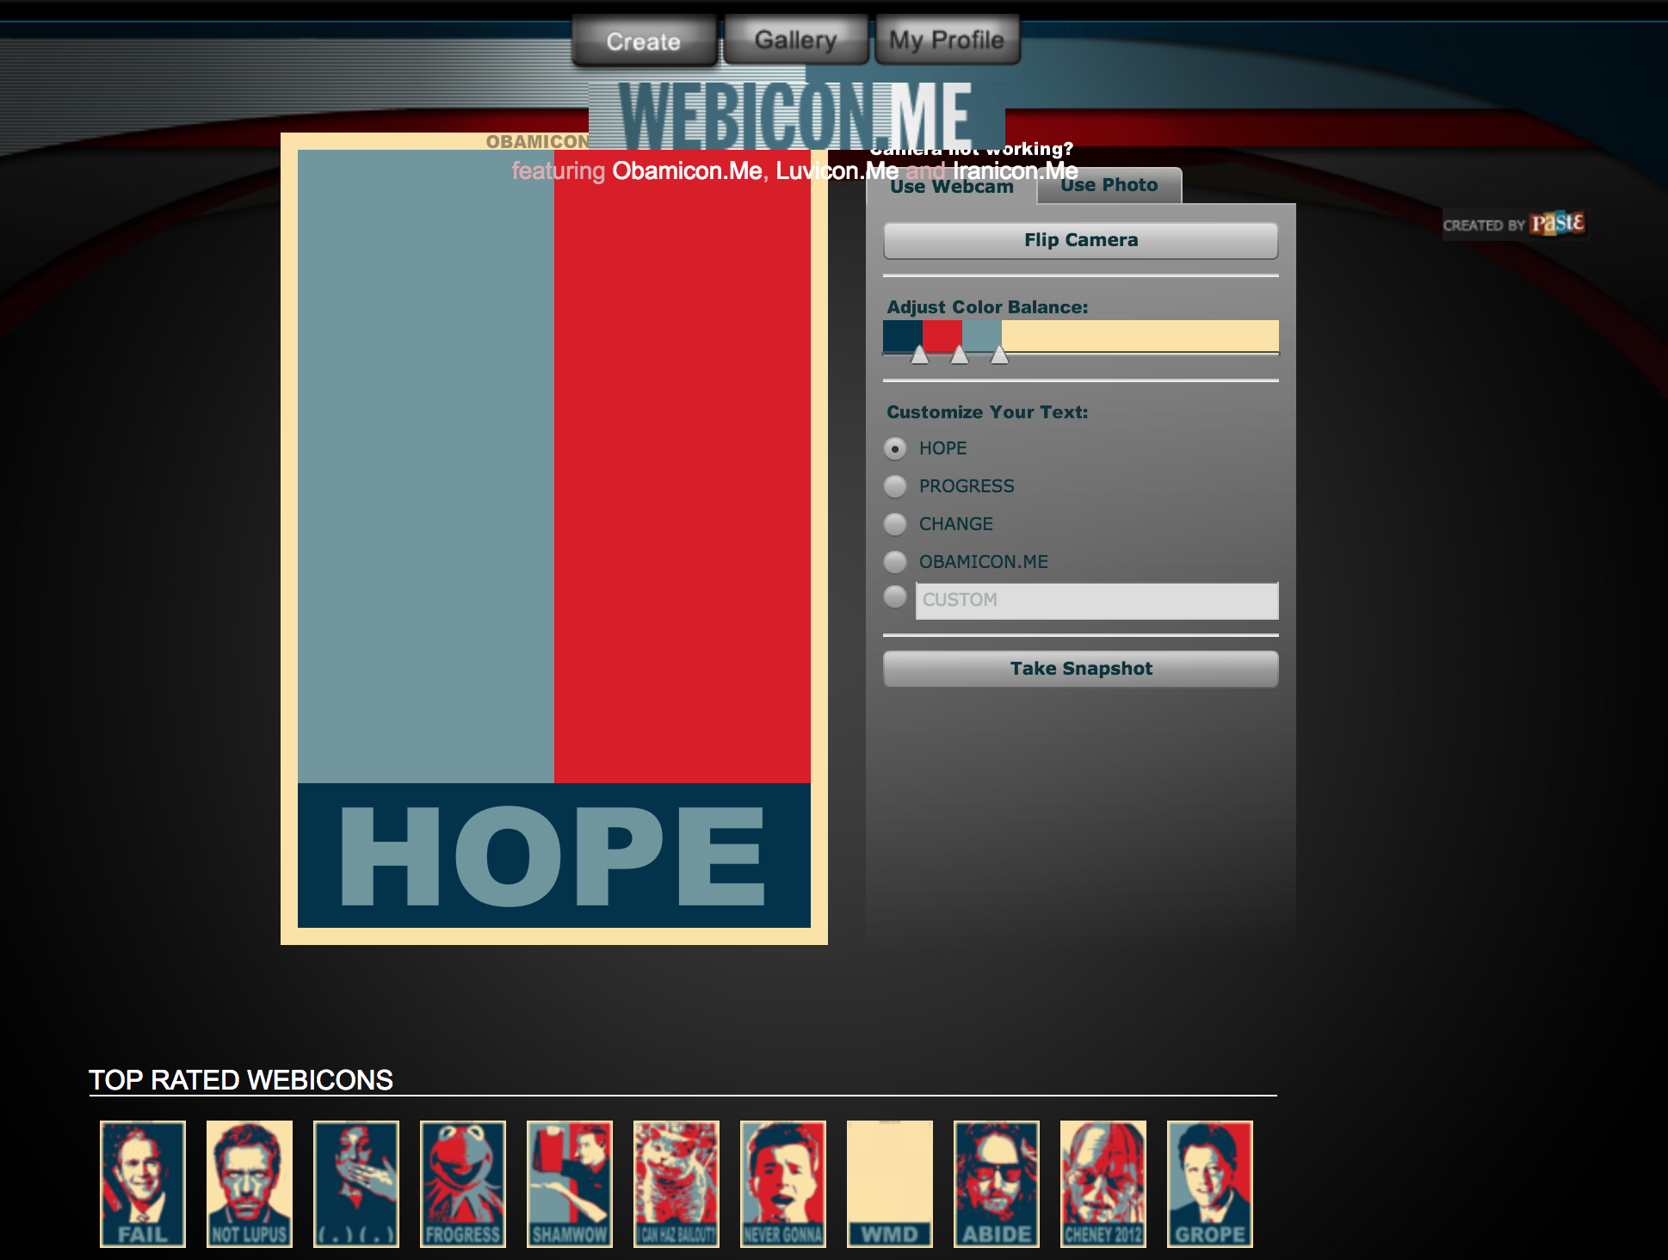

**Fig. 2**

**A screenshot of the “most recent” webicons. Below each image is a 5-star rating, an icon showing the number of coments, and a heart-shaped button to bookmark the image.**

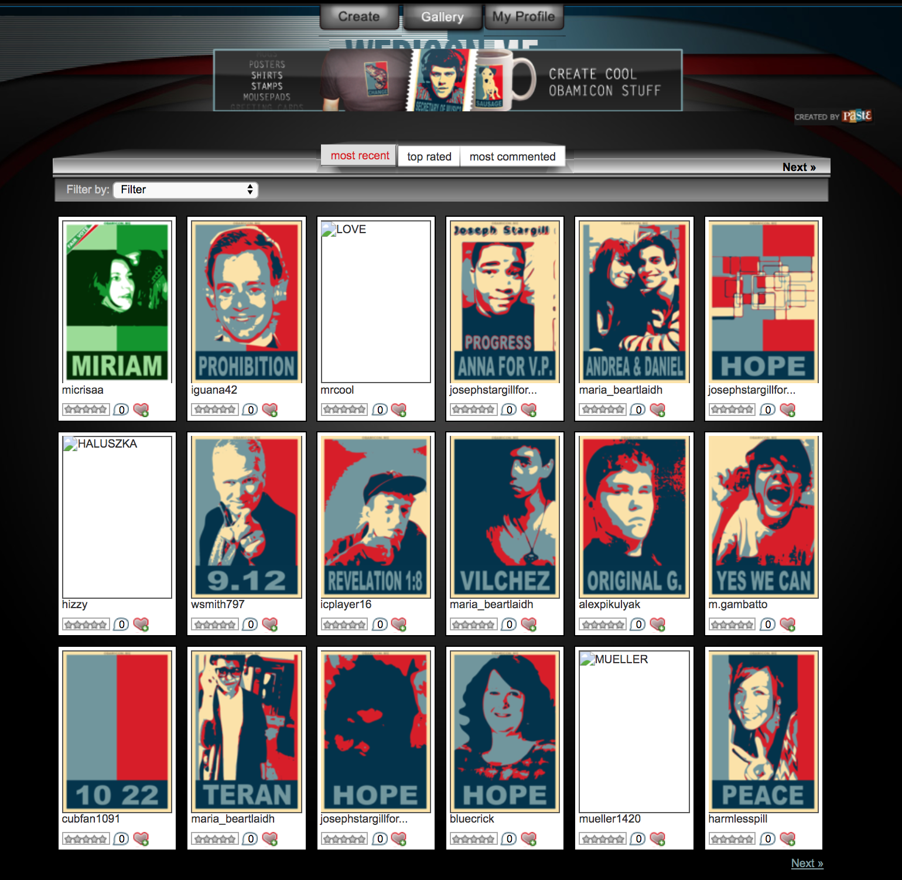

**Fig. 3**

**A screenshot of the webicon generator for the Iranicon, a green and white take on the Obama Hope image, promoted as a way to show support for “democracy in Iran.”**

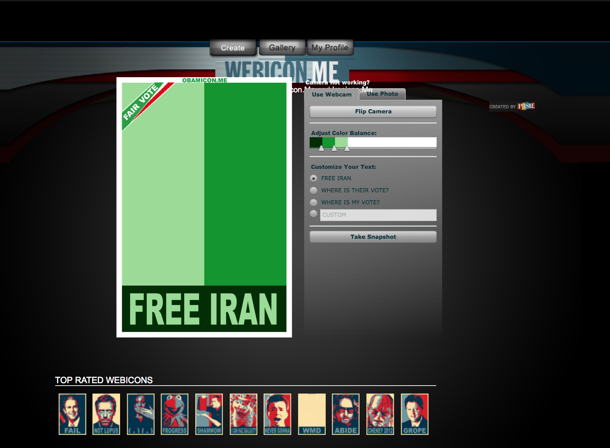

**Fig. 4**

**A screenshot of the webicon generator for the Luvicon, a virtual Valentine’s Day card.**

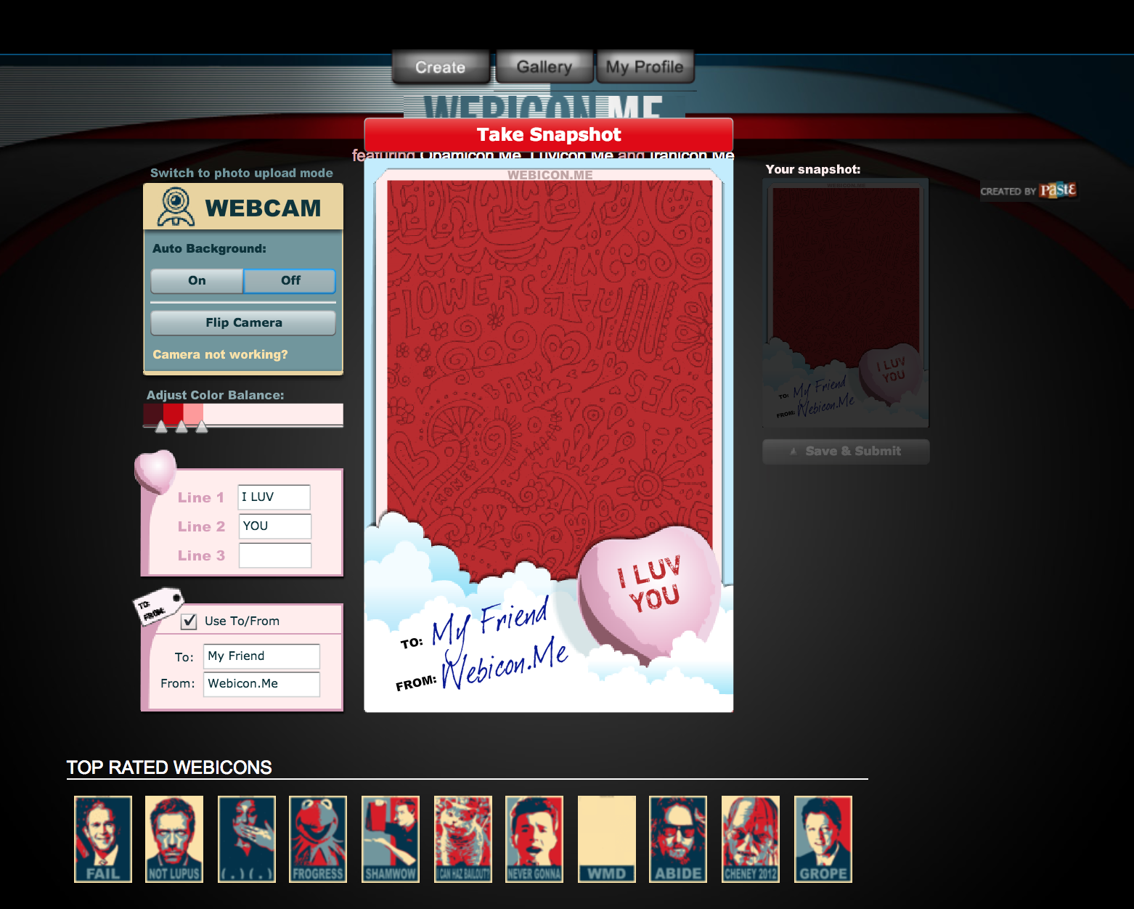

**Fig. 5**

**A screenshot showing the limited functionality of the webicon generator as it is preserved on the Wayback Machine.**

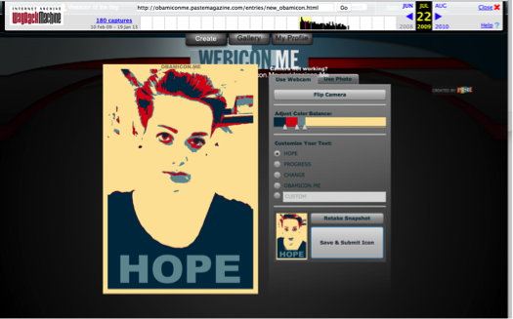

**Fig. 6**

**A screenshot of an error message that reads “The page you were looking for doesn’t exist. You may have mistyped the address or the page may have moved.”**



**Fig. 7**

**A screenshot of a glitched display of the login site to Obaicon.me.**

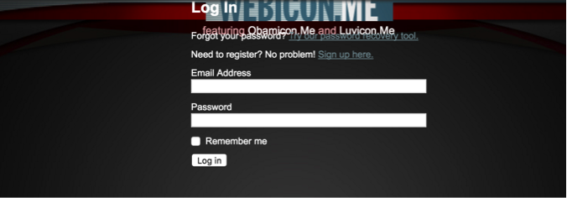

Works Cited

@obamiconme. “Obamicon.Me.” *Twitter*, 2009, <https://twitter.com/obamiconme>. Accessed 26 November 2018.

@ObamiconMe. “Obamicon.me.” *Facebook*, 2017. <https://www.facebook.com/pg/ObamiconMe/>. Accessed 26 November 2018.

Barad, Karen. *Meeting the Universe Halfway: Quantum Physics and the Entanglement of Matter and Meaning*, Duke University Press, 2007.

Bayerl, Petra Saskia, and Lachezar Stoynov. “Revenge by Photoshop: Memefying Police Acts in the Public Dialogue about Injustice.” *New Media & Society*, vol. 18, no. 6, 2016, pp. 1006–26.

Boczkowski, Pablo and Leah A. Lievrouw. “Bridging STS and Communication Studies: Scholarship on Media and Information Technologies.” *The Handbook of Science and Technology Studies*, edited by Ulrike Felt, Rayvon Fouché, Clark A. Miller, and Laurel Smith-Doerr, 3rd ed., MIT Press, 2008, pp. 947-967.

Bowker, Geoffrey C and Susan Leigh Star. *Sorting Things Out: Classification and It’s Consequences*, MIT Press, 1999.

De Vries, Imar O. *Tantalisingly Close: An Archaeology of Communication Desires in Discourses of Wireless Media*, Amsterdam University Press, 2012.

Druckrey, Timothy. “Foreward.” *Deep Time of the Media: Toward an Archaeology of Hearing and Seeing by Technical Means*, edited by Siegfried Zielinksi, translated by Gloria Custance, MIT Press, 2006.

Duffy, Sean. “Obamicon Yourself!” *Social Media Today*, 22 January 2009, <https://www.socialmediatoday.com/content/obamicon-yourself>.

Easterbrook, Steve. “On the Uses and Abuses of Infrastructural Inversion.” *Serendipity: Applying Systems Thinking to Computing, Climate and Sustainabilitly*, 2010, <http://www.easterbrook.ca/steve/2010/08/on-the-uses-and-abuses-of-infrastructural-inversion/>.

Edwards, Richard L. “Flip The Script: Political Mashups as Transgressive Texts.” *Transgression 2.0: Media, Culture, and the Politics of a Digital Age*, edited by Ted Gournelos and David J. Gunkel, Continuum, 2011, pp. 26–41.

Elsaesser, Thomas. 2016. “Media archaeology as symptom.” *New Review of Film and Television Studies*, vol. 14, no. 2, 2016, pp. 181-215.

Ernst, Wolfgang. *Digital Memory and the Archive,* edited by Jussi Parikka, University of Minnesota Press, 2013.

“Explore #obamicon.” n.d. *Deviant Art*.

Fairey, Shepard. “Spreading the Hope: Street Artist Shepard Fairey.” *Fresh Air* on *National Public Radio*, 2009, <http://www.npr.org/templates/story/story.php?storyId=99466584>.

Fickers, Andreas and Anne-Katrin Weber. “Towards and Archaeology of Television.” *View: Journal of European Television History & Culture*, vol. 4, no. 7, 2015, pp. 1-6.

Finnegan, Cara A. “Doing Rhetorical History of the Visual: The Photograph and the Archive.” *Defining Visual Rhetorics*, Erlbaum, 2004, pp. 195–213.

FOLIO: Magazine Staff. 2009. “Tim Regan-Porter.” *FOLIO*, March.

Fuller, Steve and James H. Collier. *Philosophy, Rhetoric, and the End of Knowledge: A New Beginning for Science and Technology Studies*, 2nd edition, Erlbaum, 2003.

Garland, David. “What is a ‘history of the present’? On Foucault’s genealogies and their critical preconditions.” *Punishment & Society*, vol. 16, no. 4, 2014, pp. 365-384.

Garun, Natt. “Photobucket Accues of Blackmail after Quietly Requiring Users to Pay $400 a Year to Hotlink.” *The Verge*, 4 July 2017, <https://www.theverge.com/2017/7/4/15919224/photobucket-broken-images-amazon-ebay-etsy-paid-update>.

Gries, Laurie. *Still Life with Rhetoric: A New Materialist Approach for Visual Rhetorics,* Utah State University Press, 2015.

--- “Obama Zombies and Rhetorical (Dis)Identifications in an Era of Dog Whistle Politics and Political Polarizaion.” *ImageTexT: Interdisciplinary Comics Studies*, vol. 8, no. 1, 2015, <http://www.english.ufl.edu/imagetext/archives/v8_1/gries/?print>.

Helmond, Anne, David B Nieborg, and Fernando N Van Der Vlist. “The Political Economy of Social Data: A Historical Analysis of Platform – Industry Partnerships.” *Proceedings of the 8th International Conference on Social Media & Society*, 2017, ACM Press.

Huhtamo, Erkki and Jussi Parikka. “Introduction: An Archaeology of Media Archaeology.” *Media Archeology: Approaches, Applications, and Implications*, edited by Erkki Huhtamo and Jussi Parikka, University of California Press, 2011, pp. 1-17.

Jain, Ramesh. “Let’s Weave the Visual Web.” *IEEE MultiMedia*, vol. 22, no. 3, 2015, pp. 66-72.

Jenkins, Henry, Sam Ford, and Joshua Green. *Spreadable Media: Creating Value and Meaning in a Networked Culture*, NYU Press, 2013.

Lepore, Jill. “The Cobweb: Can the Internet Be Archived?” *The New Yorker*, Jan. 2015, <https://www.newyorker.com/magazine/2015/01/26/cobweb>.

Koman, Richard. “How the wayback machine works.” *O’Reilly XML.com*, 2002, <http://webservices.xml.com/pub/a/ws/2002/01/18/brewster.html>.

Mackey, Robert. “Web users make their own ‘Obamicons.’ The Lede blog on *The New York Times*, 17 Feburary 2009, <http://thelede.blogs.nytimes.com/2009/02/17/so-sue-us-web-users-make-their-own-obamicons/>.

Magee, Joan R. “Obamicon Me!.” *Upstart Business Journal*, 28 January 2009, <http://upstart.bizjournals.com/news/wire/2009/01/28/obamicon-me.html?page=all>.

Marino, Nick. 2009. “Ten Awesome Obamicon Posters.” *Paste Magazine*, 7 January 2009, <https://www.pastemagazine.com/blogs/lists/2009/01/ten-awesome-obamicon-posters.html>.

"media, n.2." *OED Online*. Oxford University Press, March 2016.

Nakamura, Lisa. “Media.” *Keywords for American Cultural Studies*, edited by Bruce Burgett and Glenn Hendler, NYU Press.

--- “Indigenous circuits: Navajo women and the racialization of early electronic manufacture.” American Quarterly vol. 66, no. 4, 2014, pp. 919-941.

Orsini, Lauren. “The Triumph of the Visual Web.” *ReadWrite*. 18 December 2013, <http://readwrite.com/2013/12/18/visual-web-2013-trends/>.

Parikka, Jussi. “Mapping Noise: Techniques and Tactics of Irregularities, Interception, and Disturbance.” *Media Archaeology: Approaches, Applications, and Implications*, edited by Erkki Huhtamo and Jussi Parikka, University of California Press, 2011, pp. 256-277.

--- *What is Media Archaeology?* Polity Press, 2012.

--- “Archival Media Theory: An Introduction to Wolfgang Ernst’s Media Archeology.” *Digital Memory and the Archive*, University of Minnesota Press, 2013 pp. 1-56.

Paste Staff. “Paste Launches Obamicon.Me.” *Paste Magazine*, 7 January 2009, <https://www.pastemagazine.com/articles/2009/01/paste-launches-obamiconme.html>.

--- “The Return of Obaicon: Create Your Own Image.” *Paste Magazine*, 27 September 2012.

Polonyi, Eszter. “Media archaeology in cinema studies and art history: a response to Thomas Elsaesser’s ‘Media Archaeology Symptom.’” *New Review of Film and Television Studies*, vol. 14, no. 2, 2016, pp. 216-221.

Regan-Porter, Tim. “Tim Regan-Porter.” *Linkedin*, 2017. Accessed November 26. <https://www.linkedin.com/in/timreganporter>.

Robertson, Adi. “The Internet Archive Is Building a Canadian Copy to Protect Itself from Trump.” *The Verge*, 29 November 2016, <https://www.theverge.com/2016/11/29/13778188/internet-archive-of-canada-backup-trump-surveillance-censorship>.

Sismondo, Sergio. *An Introduction to Science and Technology Studies*, 2nd edition, Blackwell Publishing, 2010.

*The Telegraph*. “Obamicon: Alternative Presidents,” *The Telegraph,* 15 January 2009, <http://www.telegraph.co.uk/news/picturegalleries/howaboutthat/4243021/Obamicon-Alternative-presidents.html>.

Van Hoven, Matt. “The growth of the visual Web in 5 charts.” *Digiday*. 7 May 2014, <http://digiday.com/platforms/5-charts-growth-visual-web/>.

Yoo, Alice. “Obamicon.Me - Post-Election Fun By Paste Magazine.” *My Modern Met*, 15 January 2009, <https://mymodernmet.com/obamiconme-postelection-fun/>.

Zielinski, Siegfried. *Deep Time of the Media: Toward an Archaeology of Hearing and Seeing by Technical Means*, translated by Gloria Custance, MIT Press, 2006.

--- “Media Archaeology.” *C Theory,* 7 November 1996, <http://www.ctheory.net/printer.aspx?id=42>.

1. Industry abbreviation for circulation.
2. The turn to popular culture is also evident in other archives of Obama Hope images, such as the #obamicon collection on art community site DeviantArt, although there, the references tend towards video games and anime (“Explore #obamicon”).
3. In this, media archeology has similarities with Bruno Latour’s Actor-Network Theory and other new materialist approaches to thinking about the role of things. However, media archeology need not share the ontological commitments of those approaches in full. As John Durham Peters explains,

   Bruno Latour, to whom I owe a lot, has polemically called for a “flat ontology,” but in the works of some of his acolytes that can sound like a refusal to make critical judgments about the great inequality of things. Anyone interested in infrastructure, lookouts, and turning points needs old-fashioned sociology about how recalcitrant, not just how cool, “things” are. Ontology is not flat; it is wrinkly, cloudy, and bunched. (30)
4. For example: *Grey Room* No. 43 special issue “Audio/Visual,” *Amodern* No. 2 special issue “Network Archeology,” *View: Journal of European Television History & Culture* Vol. 4 No. 7 special issue “Archaeologies of Tele-Visions and –Realities,” and *MCD: Magazine des Cultures Digitales* No. 75 special issue “Archéologie Des Média.”
5. For example: *The Book of Imaginary Media: Excavating the Dream of the Ultimate Communication Medium* , *Media Archaeology: Approaches, Applications, Implications,* and Siegfried Zielinski’s *Variantology* series.
6. Labs and institutes include the Media Archeological Fundus at Humboldt University, Berlin, the IMA Institute of Media Archeology at Hainburg, the Media Archeology Lab at the University of Colorado Boulder, and the Preservation, Archaeology, Media Art Lab at the Art School of Avignon. For more on the role of labs in research, see the forthcoming *THE* *LAB BOOK: Situated Practices in Media Studies* from Lori Emerson, Jussi Parikka, and Darren Werschler from the University of Minnesota Press <http://whatisamedialab.com/>.
7. For example: the *Network Archeology* conference at the University of Miami in 2012 and the *Media Archealogy Institute Lecture Series* at the School of Art Institute in Chicago in 2013. For a list of more events and publications related to media archeology, see the excellent collection put together at *Monoskop*, a wiki for the study of art, media, and the humanities: <https://monoskop.org/Media_archaeology>.
8. I borrow the language of the past as inventional resource from Alessandra Von Burg’s essay “Stochastic Citizenship: Toward a Rhetoric of Mobility.”
9. Although scholars who identify with a media archeology approach often use this framing to distinguish it from media history, the distinction is a bit misleading and is more applicable to some of the foundational works in media history research such as Lewis Mumford’s *Technics of Civilization*. More recent forays in media history often share media archeology’s rejection of dominant narratives, tidy periodizations, and universal claims. See John Durham Peters’ *The Marvelous Clouds* as an example.
10. The idea of infrastructural inversion can be productively thought of alongside Martin Heidegger’s distinction between ready-at-hand and present-at-hand. For Heidegger, these phrases refer to particular ways of apprehending tools. The ready-at-hand mode approaches a tool as an object to be used for a particular and pre-established purpose; in so doing, it takes the existence of the object for granted. The present-at-hand mode approaches a tool as a thing in its own right, a fuller experience of encounter. When a tool breaks down or malfunctions, it may prompt one to change from a ready-at-hand orientation to a present-at-hand orientation. The idea of infrastructural inversion gets at a similar change in orientation to the world, but the object of the orientation differs. Where Heidegger is concerned with the relationship between a person and a particular object, infrastructure refers to a larger system that extends beyond any individual object and by its nature affects many people. See (Easterbrook) for a more detailed account of the relationship between infrastructural inversion and Heidegger’s work.
11. In bringing the attention to infrastructure from Science and Technology Studies to Media Archeology, I support claims of compatibility between media and information technologies, communication, and science and technology studies (Boczkowski and Lievrouw).
12. Ownership of servers is a crucial mechanism of control for online content. If one owns the servers responsible for hosting a site as *Paste Magazine* did, then one has the authority to determine whether the site is available online. A similar dynamic of control was at work in the closure of early personal webpage community *GeoCities*, which was taken offline by *Yahoo!* in 2009. Although individual users can save copies of their content to their personal machines or make it available through other locations online, such as posting their Obamicon on a blog or social network site, without access to the original files and control of a server, there is no way to preserve the full context and functionality of a site online.
13. See Helmond et al. for an interesting exception. Here, the researchers were interested in tracing a history of Facebook’s commercial partnerships and used cached images of Facebook’s news and advertising pages, along with industry blogs, to create a timeline.
14. This trend of commemorating notable political events and natural disasters continues today with the availability and popularity of Facebook profile picture filters.